**Assignment 12: State Design Pattern**

**What is State Design Pattern?**

**State** is a behavioural design pattern that lets an object alter its behaviour when its internal state changes. It appears as if the object changed its class.

**Structure (Class Diagram)**

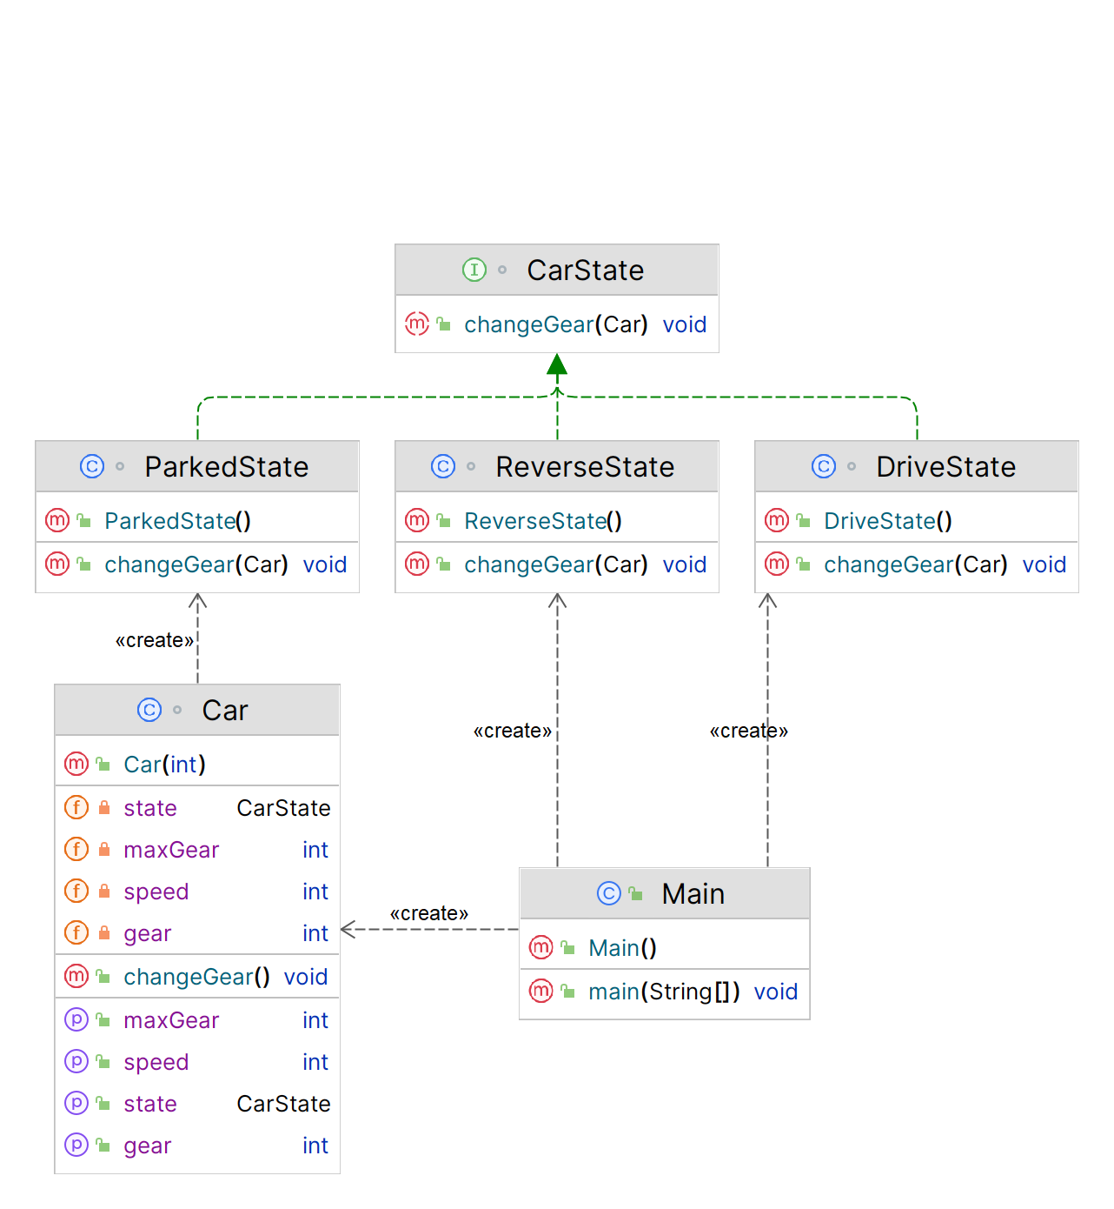

**Implementation (Code)**

|  |
| --- |
| *// Interface for CarState* interface CarState {  void changeGear(Car car); }  *// Concrete class for ParkedState* class ParkedState implements CarState {    public void changeGear(Car car) {  *// Car can only change gear when it's not parked* System.*out*.println("Cannot change gear while car is parked.");  } }  *// Concrete class for DriveState* class DriveState implements CarState {  public void changeGear(Car car) {  *// Car can change gear to higher gear when driving at certain speed* if (car.getSpeed() < 20) {  System.*out*.println("Cannot change to higher gear when car is moving slowly.");  } else if (car.getGear() >= car.getMaxGear()) {  System.*out*.println("Cannot shift to higher gear, already in top gear.");  } else {  car.setGear(car.getGear() + 1);  System.*out*.println("Changed gear to " + car.getGear());  }  } }  *// Concrete class for ReverseState* class ReverseState implements CarState {    public void changeGear(Car car) {  *// Car can only change to reverse gear when speed is 0* if (car.getSpeed() > 0) {  System.*out*.println("Cannot shift to reverse gear when car is moving forward.");  } else {  car.setGear(-1);  System.*out*.println("Changed gear to reverse");  }  } }  *// Context class for Car* class Car {  private int speed;  private int gear;  private int maxGear;  private CarState state;   public Car(int maxGear) {  this.speed = 0;  this.gear = 0;  this.maxGear = maxGear;  this.state = new ParkedState();  }   public void changeGear() {  this.state.changeGear(this);  }   *// Getters and setters for speed, gear, and maxGear* public void setSpeed(int speed) {  this.speed = speed;  }   public int getSpeed() {  return this.speed;  }   public void setGear(int gear) {  this.gear = gear;  }   public int getGear() {  return this.gear;  }   public int getMaxGear() {  return this.maxGear;  }   *// Method to set the state of the car* public void setState(CarState state) {  this.state = state;  } }  *// Example usage* public class Main {  public static void main(String[] args) {  Car car = new Car(4);   *// Car starts in parked state* car.changeGear(); *// Output: "Cannot change gear while car is parked."   // Car can shift to reverse gear when speed is 0* car.setState(new ReverseState());  car.changeGear(); *// Output: "Changed gear to reverse"   // Car cannot shift to higher gear when moving slowly* car.setState(new DriveState());  car.setSpeed(10);  car.changeGear(); *// Output: "Cannot change to higher gear when car is moving slowly."   // Car can shift to higher gear when moving at certain speed* car.setSpeed(25);  car.changeGear(); *// Output: "Changed gear to 0"* car.changeGear(); *// Output: "Changed gear to 1"* car.changeGear(); *// Output: "Changed gear to 2"* car.changeGear(); *// Output: "Changed gear to 3"* car.changeGear(); *// Output: "Changed gear to 4"   // Car cannot shift to higher gear when already in top gear* car.changeGear(); *// Output: "Cannot shift to higher gear, already in top gear"* } }  **Output** |

**Applicability**

1. Use the **State pattern** when you have an object that **behaves differently** depending on its current state, the number of states is enormous, and the **state-specific code** changes frequently.
2. Use the pattern when you have a class polluted with massive conditionals that alter how the class **behaves** according to the current values of the class’s fields.
3. Use State when you have a lot of **duplicate** **code** across similar states and transitions of a condition-based **state machine**.